**Template of the one-page Abstract for the 11th conference on Quantum Simulation and Quantum Walks**

Q. Simulation, Q. Walk

Institute for Momentary Research,

Straight Path to Answer 42, 1926 Neverland, USA

[quantum@walks.it](mailto:quantum@walks.it)

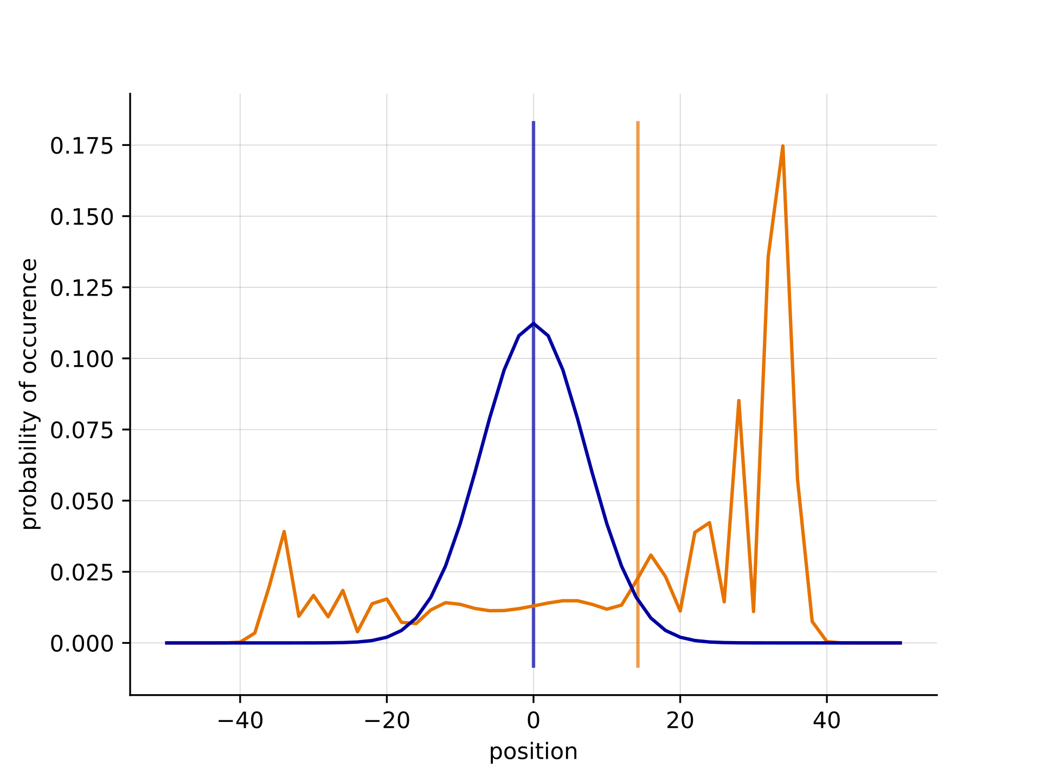

This document is an example of a one- page Abstract prepared for the 11th conference on Quantum Simulation and Quantum Walks QSQW2025. The full Book of Abstracts will be only published online.

The goal of the Book of Abstracts is to inform the audience about the papers being presented. Therefore, please make sure that this page contains all necessary information about the work you are going to present. Please, try to make it attractive and informative at the same time. Aiming at this, you can also include one figure, such as Fig. 1, and a few (optional) references, such as [1] or [2].

The one-page abstract must be written in English and prepared as a one-page, A4 PDF file (size 210*_*297 mm) using the Times font, 18 pt for the title, 13 pt for the authors’ names and affiliations, and 11 pt for the text. The left and right margins should be 3.5 cm, the top margin 3 cm and the bottom margin 2 cm. Please do not exceed these limits, or your PDF file will not be accepted. The page could be scaled down slightly by further editing, so please make a clear and simple figure. We strongly recommend to use the LATEX or MS Word templates pro- vided on the conference website in order to ensure the correct formatting.

Please also note that this abstract must be uploaded on the conference management system before the "abstract submission deadline", and that at least one author should have registered before the "early registration deadline", for the final paper to be included in the conference programme.

Fig. 1: Probability distribution resulting from 1D discrete time random walks. The quantum walk created using the  Hadamard coin is plotted (orange) vs a classical walk (blue) after 50 time steps. Source: <https://en.wikipedia.org/wiki/Quantum_walk>.

We hope you will enjoy QSQW2025 and we are looking forward to have you here.

**References**

[1] Author, I.A.M, Nothing Id.Id., A Structure for the Conventional Paper, Nature Matters 71, 89-144, 1905.

[2] More O.N.E, Helpful A.Th.R., Physi- cal Systems of Spotless Minds, Unco- herent Engineering Practices, pp. 666- 999, 1960.